Week 1
Arriving mid-afternoon to the busy Beijing airport I was welcomed by my lab advisor Mr. Yao Shengze, he would be crucial to my survival over the next few weeks. First observation about China: driving here is an art. We bobbed and weaved past the Birds Nest through Beijing traffic. It seemed that turn signals were optional and car horns were a language all their own. The orientation period was a whirl wind, as my advisor and I ran from one end of campus to the other, getting photos taken for IDs, registering me with the Chinese police, and fully settling into my new dorm room. My wallet swelled as I filled it with a room card, laundry card, ID card, lab card, meal card, subway card, medical card, and strange money, which to the untrained American eye may be mistaken for monopoly bills. Despite my best efforts to beat jet lag I woke at 4:30 and figured I may as well explore my surroundings. Slowly the calm of the waking city was burst as 21 million people filled the streets of Beijing, quite a departure to the calm of rural Indiana. Entering some of the surrounding building complexes, I found myself in a maze of half-built computers and exposed circuitry six stories high. Apple screens to the left, home security cameras to the right, the smoke of solder irons in the air, and hundreds of people zipping in between the shops. This in stark contrast to the serene campus of Peking University, with its tranquil lakes, and traditional Chinese architecture. Wandering deep into the forested gardens, you’ll forget your in one of the busiest cities in the world. The street corners here are awash in ride share bikes scattered around in their various colors and styles, and there seems to be a moped for every man, woman, and child here. Eventually I was taken to the lab to begin my research. The lab was impressive to say the least: clean, sophisticated, and humming with the sounds and smells of biological science. My lab mates were all eager to meet me and practice their impressive English skills. Here I met Mr. Yi Li, the vibrant and encouraging lab director. During my initial acclimation to the lab I felt rather confident, coasting on my previous knowledge on genetic fundamentals: reverse transcription, PCR, gel electrophoresis. Yet by the third day my initial confidence was throughly shattered. The level of research being done was bleeding edge. My lab mates were ridiculously smart and dedicated, working 10-14 hour days, 6 days a week. After the initial shock and excitement was over I came to a realization, it’s just me. I had attended a military boarding school for the past four years, and thus was expected to exhibit a certain level of self-regulation and independence. Yet this was a whole new level of autonomy. So, feeling symbolic while doing my first round of grocery shopping, I made a purchase marking my transition into adulthood: I bought a succulent. New country, new language, new plant, new me.
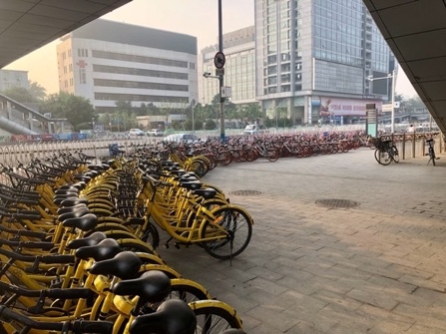
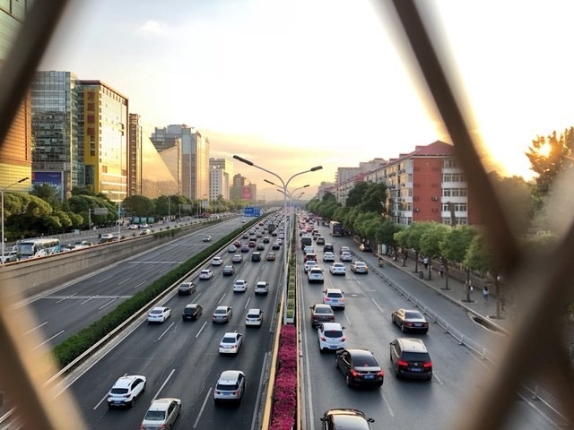
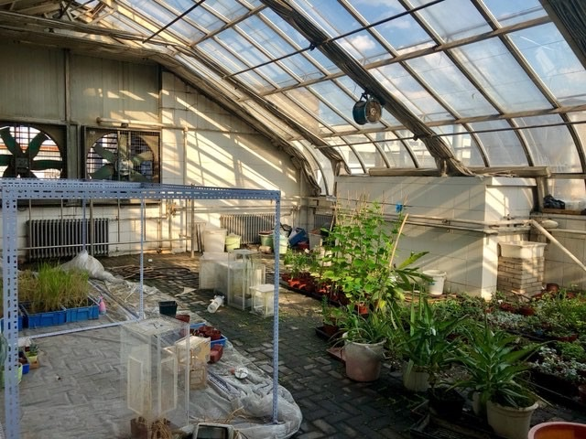
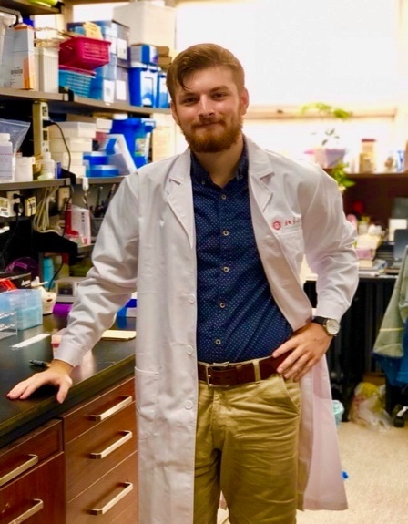

Week 2
This week I had the fortune of meeting up with some of my high school friends who live in Beijing. I was given the day of for the Dragon boat holiday, and we decided to take a day trip exploring the city. They introduced me to Qianmen Street, a historic market district on the central axis of the city. The pedestrian street was a mix of Qing and modern architecture, dotted with shops selling Beijing street food, jewelry, and clothes. It was nice to see familiar faces, and it helped to have them teach me the nuances of Chinese city life. By the second week, the smog free skies have given way to a grey and muggy atmosphere, and the language barrier became more pronounced as I pushed further outside of the university and met new people. Mobike became my new best friend. The bike sharing app allows you to quickly scan a bike and ride from about 0.15 USD per ride, a god send in the sprawling metropolis. On the science side, I’m starting to become accustomed to the rhythm of the lab, and more comfortable with the machines and procedures. I have spent much more time planting, and sampling in the green house. While this gives me plenty of hands on experience with the plants, the greenhouse is an invariable sauna where walking feels more like swimming. Later in the week Mr. Yao and myself took a trip to Nanjing, a city 1000kms southeast of Beijing, to transfect some of our samples with the R3 virus. Given the significant distance we opted to take a bullet train, needless to say I was not disappointed. The rail station’s security process and boarding times were far superior to any airport, and the cabin itself was far roomier and lacked that ever present pressure felt at high altitudes. The sunny Chinese country side zipped pasted smoothly, interrupted only by the occasional whoosh as we passed through a city, brushing feet away from a skyscraper or fellow bullet train. The city was filled with bright lights and rainy streets, more analogous to Blade Runner than any city Id ever seen before. Over all the week was fantastic, if at times challenging, and I’m looking forward to the days ahead.
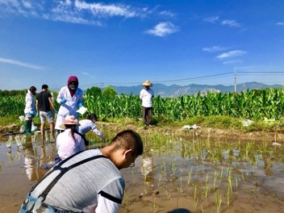
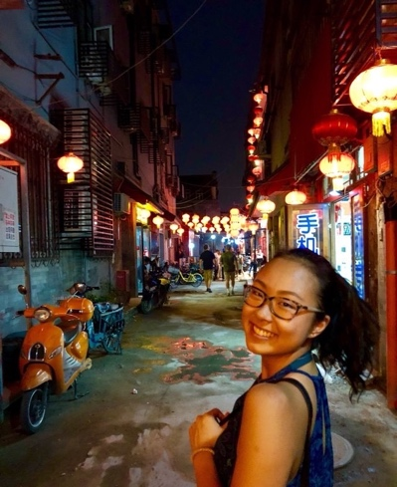
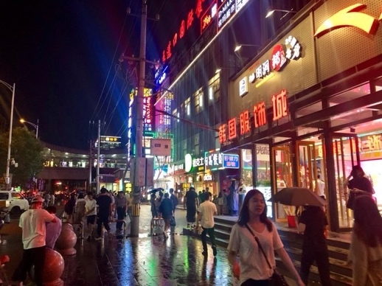
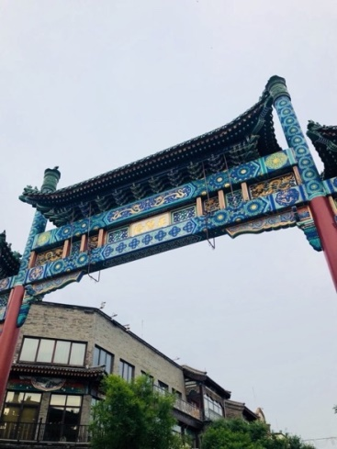

Week 3
I have a bit of a confession. For the past two weeks I have been doing my laundry in my bathroom sink, with varying degrees of success. I knew there were washing machines somewhere on campus but hadn’t yet been able to find any. I spent about 4 hours this Sunday scouring the campus for the elusive machine, only to find it 10 feet down the hall from my dorm room. Additionally, I just figured out that the bowl I bought for eating meals in my dorm is in fact a dog bowl. So maybe I’m not quite as independent as I’d like but hey progress is progress. In the lab we have made a lot of progress recently, conducting Western Blot analysis of samples to determine protein presence and moving onto insect cell transfection. I’m really starting to understand the broader scope of the entire labs research in plant science, and I feel more confident on the fundamentals of my project (even if a lot of the high-level stuff still goes over my head). I have also ventured out further into the university campus itself and deeper into its lakes and gardens, its style shifting from the traditional Boya Tower to the ultra-modern law building. The highlight of the week for me was my trip across Beijing to The Silk Market. The market is one giant tourist trap, selling everything from Rolexes to Jordan sneakers, all fake of course. The markets signature is its intense haggling system. The sales people are fluent in English, Spanish, Korean, and Russian, and accept any currency on earth. I ended up buying a Beijing souvenir t-shirt, and quickly found out the I was significantly outmatched in bargaining ability. On my way back from the market I decided to stop and visit Tiananmen square. While I had become accosted to high levels of security in the city, the square was a whole new level of secure. Cameras captured every movement, and guards were stationed at every corner. The security of the square was only matched in its enormity. The military parades I had seen on TV had failed to give a sense of true scale. This week has been rougher than expected, but ultimately getting out of my comfort zone has definitely helped me explore and understand more of China.
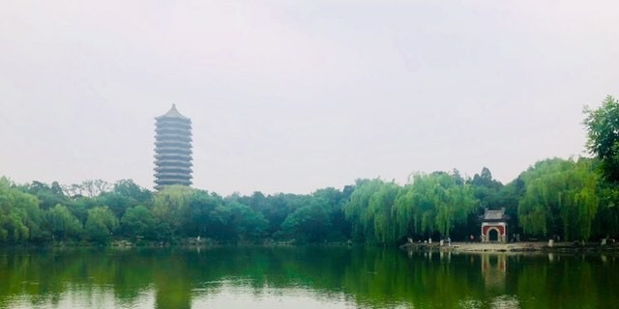
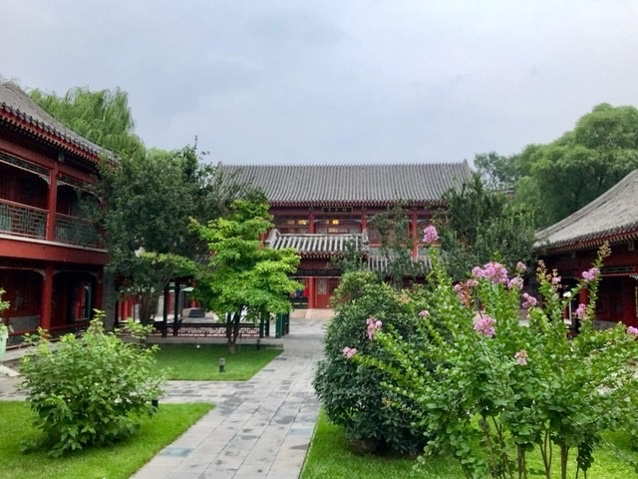
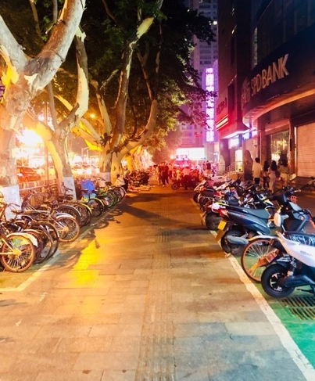
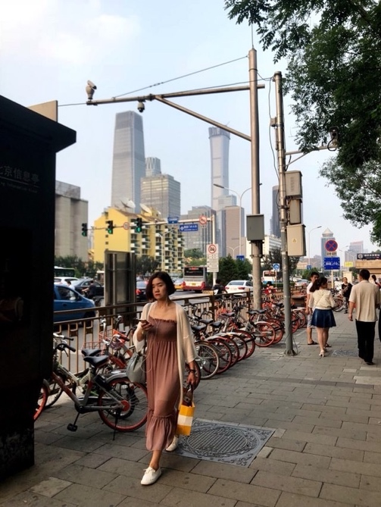

Week 4
This week has been absolutely mind blowing. In order to do a protein quantification assay (examine proteins within specific plant cells) my advisor took me over to the Analytical Instruments Center, where I got to use an electron microscope. In my excitement I didn’t know whether examine every operation closely, or to stand on the other side of the room in fear of the machine’s million-dollar price tag, and its thousand dollar per hour cost. The machine was housed in a massive building filled with similarly complicated, and expensive machines. The enormity of the complex over whelmed me, and for the first time I felt like I understood just how many millions of dollars, and billions of man hours are being poured into making the world a better place, and I felt proud to be a part of that. This week on “Charles hasn’t quite figured out how to take care of himself yet”: hot ramen. I love ramen, it was an unhealthy staple of life in high school, and I love hot things so hot ramen seems like a logical conclusion. What I failed to equate was that 1.) this was not the American definition of hot 2.) I was running dangerously low on drinking water. I was left to contemplate my errors as I ran my head under the faucet to cool down. This Friday Professor Li took me out with some of his colleagues to play basketball and have dinner. While table tennis may be china’s national sport, basketball is certainly it’s most popular. Everyone was decked in head to toe with Jordans and Nike attire, and with the skills to match. It wasn’t long before my ankles were broken and the professors were shooting threes over my head. Afterwards I was treated to my first hot pot ever, and both the food and atmosphere were very distinct to anything I had in the states. Food came out gradually over two hours, and the five of us talked about everything from US gun laws to China’s national hero: Yao Ming. The slower pace was a distinct departure from eating out in America. I have come to really enjoy these types of long dinner conversations, and the slower pace of social life in China in general.
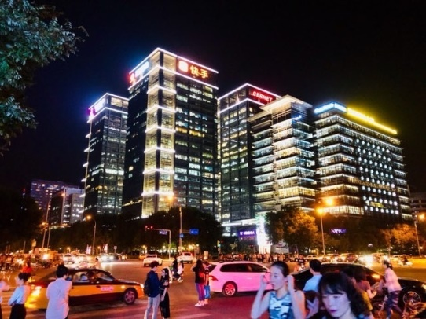
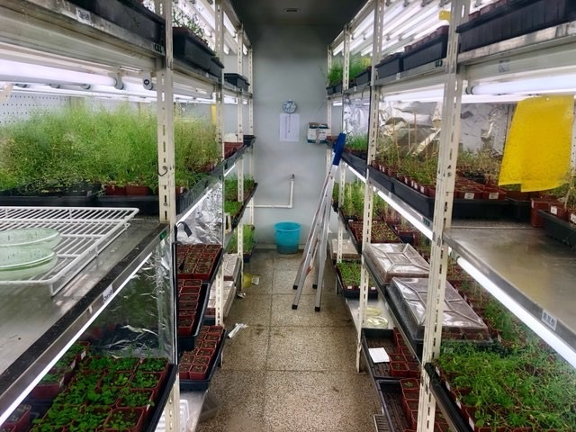
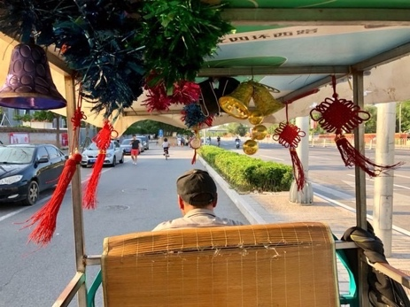

Week 5
I have begun tutoring Professor Li’s son Michael in my free time. He will be taking his high school entrance interviews soon, and who better to practice English with than a native English speaker. Talking to him has given me some awesome insights about youth culture and pastimes in China. It’s interesting to see how international some of the cultural memes of young people seem to be. Michael is the same age as my younger brother and plays all the same video games, knows all the same celebrities, and watches all the same youtubers. It’s interesting, given the stark contrasts in culture that have defined my china experience, to see these commonalities emerge among the younger generations. The samples we infected in Nanjing were reaching a stage of maturity where we could to measure their growth relative to one another. To demonstrate mutant vs wild type development, we had a plant photo shoot, setting up a makeshift studio in the greenhouse. On the way back our ride service was down, forcing us to jog rather hastily through the humid streets back to PKU to preserve of frozen plant samples. Anything in the name of science, right? This weekend I met up with Rohan and Elijah and we headed to the Great Wall. The day started off rainy, yet by the time we reached to foot of the mountains the sky had begun to clear. This left us with a cool but stunningly clear sky, making for perfect climbing weather. The wall was crowded to say the least, a problem compounded by the extremely steep slopes and near vertical staircases. It was never the less breath taking. The wall winding through the gorgeous mountain vistas was sight to behold that held up to its hype. While there we saw quite a few other foreigners, yet nonetheless the three of us were asked to hold quite a few people’s babies and take quite a few photos. Where did we eat after visiting one of China’s most famous cultural icons? KFC of course. (Fun fact: KFC makes more money in China than the United States.) I have gotten to the point in my trip where I feel comfortable with my surroundings. I have come to terms with the new sights, sounds, and tastes, and I feel at ease being totally on my own, even if the language barrier still at times poses difficulties. I can already feel that I am going to miss China when I leave.
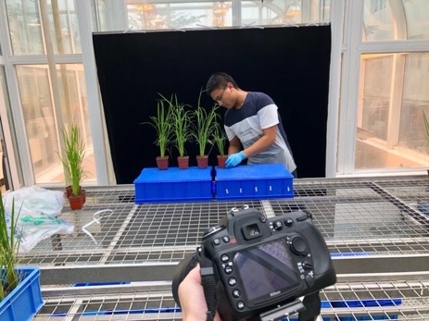
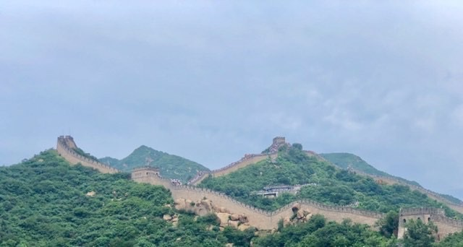
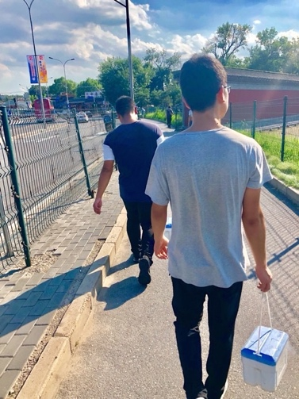
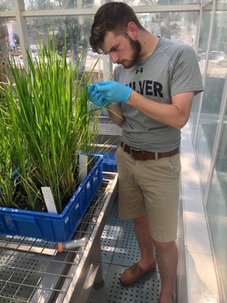
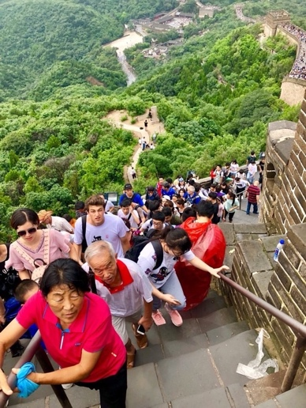
Week 6
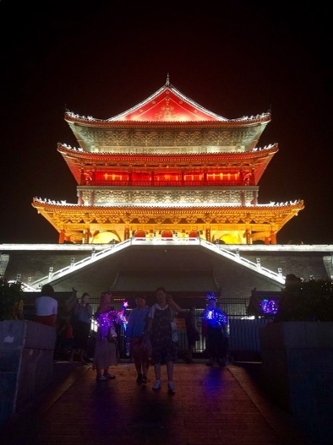
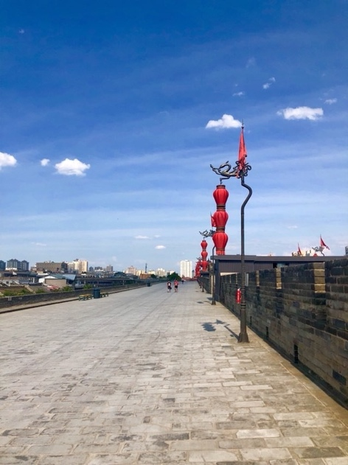
This week I embarked a trip to the home city of my lab director Dr. Li, the city of Xian in northwestern China. The city, and the Shaanxi province as a whole, retain much of their ancient heritage, and are littered with unfrequented historical sites. One of the highlights of the trip was my visits to the Muslim quarter of the city. The outdoor markets sold food of every variety, and as the sun went down, string lights lit up the shops and hung from the overhanging trees. My new found friend, the son of one of Dr. Li’s collogues, made sure I was well fed, helping me try everything from lambs foot to roasted squid. Over the course of the week we would tour the Chinese country side, giving me a chance to see what life was like in more rural areas in china. Out there I was a bit of a demographic oddity and stares were quite common, especially from kids. Yet I never felt unwelcome and was always greeted with enthusiastic, if curious, smiles. We ventured out fairly far, visiting Northwestern A and F University and the Wei River in Yangling. I even went to see the terracotta warriors and was taken back by how intricated the excavation sites were, and how many more were still yet to be uncovered. At one point in our journey we stopped at the Qianling Mausoleum, a tomb containing China’s only female emperor. Four massive citadels stood guard at the corners of the small mountain range and in between them ran an arching cobblestone road lined with statues of statesmen and clerks of the dynasty. The mountain climb proved a bit more treacherous than expected with the brick road giving way to a well-worn foot path dotted occasionally with small vendors peddling trinkets and hats. The hot climb up proved to be well worth the view from the top. At the mountain’s pinnacle you could see the distant cities reach into the country side until there was nothing but farm land and mountains. In a sense you could see the Chinas development unfold as bullet trains began to jut out from the hills, and irrigation canals snaked through the fields. This has easily been one of my favorite weeks in China, from the great food to astounding views it’s been great. I’m glad that it’s given me a much broader view of what Chinese life looks like outside of the major cities.
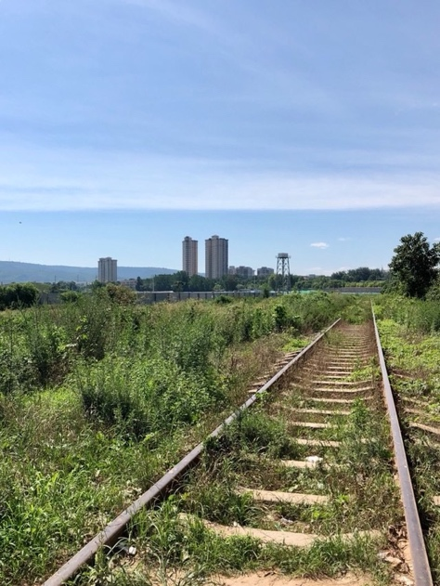
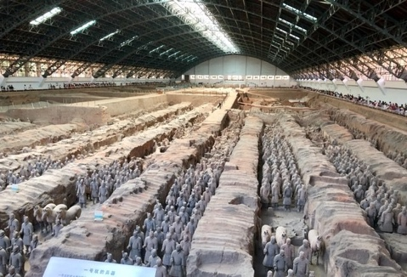

Week 7
Given my imminent departure Dr. Li decided we should have a special farewell dinner. Here I met Dr. Li’s daughter who had just graduated from college in American, who helped me translate, and shared some of her stories as a foreign student in the US. The dinner itself was a surreal experience. We all sat in a traditional Mongolian yurt and ate Mongolian food while people in full ceremonial garb sand and danced around us. On Friday I was given some time off from the lab and decided to visit the last Beijing landmark on my list, The Summer Palace. The Palace was massive complex of temples, gardens, lakes, shops, and bridges. Its beauty was only matched by its enormity. A series of ferry boats took me around the various temple complexes, and decorative bridges. I was only able to see 1/3 of the entire park despite spending an entire day there, and if I ever return to Beijing I will certainly return to see the rest. As I prepare to leave I have begun working on culminating all the data I can regarding my research. The research is still ongoing by Mr. Shengze so I must make sure that I do not present any research preemptively. I can now fully appreciate the opportunity I have been given, and the tremendous amount The research is still ongoing by Mr. Shengze so I must make sure that I do not present any research preemptively. I can now fully appreciate the opportunity I have been given, and the tremendous amount of work that has been done to put me where I now am. Someone once told me that life should be filled with unpayable debts to the people, and I am happy to report that I will forever be indebted to all of those who worked tirelessly, both at PKU and WFP, to give me this once in a life time opportunity.
